5.2.1 The Definite Integral

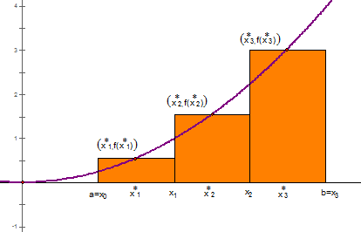
In the last section we discussed how we could approximate areas of regions using areas of rectangles.

Each rectangle had an equal width of .

Each rectangle had a height of .

Definition: The net area (also called signed area) of a region that lies between the x-axis and the graph of a continuous function may be approximated with a Riemann sum which is a sum of the form
where is a sample point in and .

Example 1: Consider the area between the function and the x-axis on the interval . We will approximate this area using a right endpoint estimate with 4 rectangles.
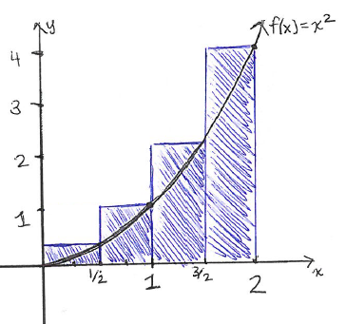
- Carefully draw and label a graph representing this approximation.

- Express this approximation for the area using sigma notation.
We know the following:
Width of Rectangles | Right Endpoints | Height of Rectangles
Therefore we can say that:
Question: When it comes to Riemann sums what do we need to modify in order to improve our approximation? Could we use a Riemann sum to obtain the actual value of the net area?

It appears that if we were to increase the number of rectangles that were used we could improve the approximation. To obtain the actual value for the net area we should take the limit as n approaches infinity.

Note: In class we looked at a computer demonstration of this idea.

Definition: Suppose that is a Riemann sum which approximates the net area A of a region that lies between a continuous function f and the x-axis. Then,

Note: It can be shown in higher level math courses (namely real analysis) that the limit in the above definition will be the same regardless of which sample points are used. For simplicity, we will usually choose to do a left endpoint or right endpoint sum when applying this definition.

Example 2: Let A be the area of the region that lies under the graph and above the x-axis of between . Using right endpoints, find an expression for A as a limit.

We know the following:
Width of Rectangles | Right Endpoints | Height of Rectangles

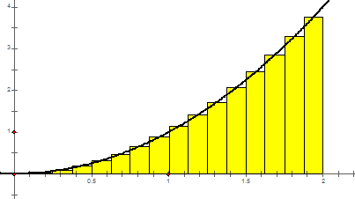
Therefore we can say that:

The next logical question to ask would be “How can we evaluate a limit like this?”
At times it is surprising easy to compute such limits if we are aware of the following facts:
These facts can be shown using the idea of Mathematical Induction which is proof technique often discussed in Precalculus.
Example 3: Determine the exact area between and the x-axis on the interval .

We saw in Example 2 that this area was given by . We now attempt to compute this limit.

Therefore the exact area of this region is !

Definition: Suppose is a function defined on . Suppose we divide into n subintervals of width . We let , , , …, and be the endpoints of these subintervals, and we let , , …, and be sample points in each of the subintervals.

Then, the definite integral of f from a to b is:

provided that this limit exists and gives the same value for all possible choices of sample points.
If it does exist, we say that is integrable on .

Note: We should read as one large symbol which indicates a net area.
Note: This definition allows us to choose any sample point in each subinterval. We will often choose the right endpoint for simplicity.
Terminology:
- The symbol is the integral sign.
- For , is called the integrand.
- For , a and b are called the limits of integrations. Specifically, a is the lower limit and b is the upper limit.

- We think of dx as indicating the variable of integration.

Example 4: Consider . Draw a picture of the net area that this definite integral represents. Based upon your picture what would you suspect this definite integral is equal to?
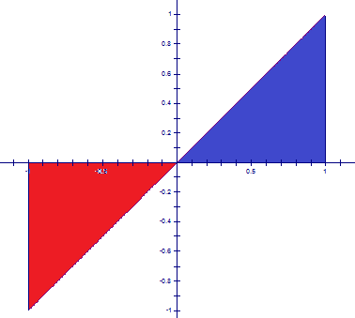

We know that the blue area is counted as positive and the red area is counted as negative.
So, we suspect that .

Note: A definite integral is a number; it does not depend on the variable of integration.
So, .

One should notice that in our definition of definite integral we did not assume that the function of integration was continuous. The next theorem tells us that most functions we run into are in fact integrable.

Theorem: If is continuous on , or if only has a finite number of jump discontinuities on , then is integrable on ; that is, the definite integral exists.

Proof: Beyond the scope of this course
In order to evaluate definite integrals we need to know how to work with sums. The following formulas for sums will be needed.

Example 5: Calculate the definite integral .
We use the definition of the definite integral to set up the following:
Width of Rectangles | Right Endpoints | Height of Rectangles
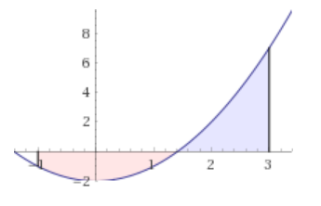

Therefore we can say that:

We then calculate:
So we say that .
Example 6: Calculate the definite integral .
We use the definition of the definite integral to set up the following:
Width of Rectangles | Right Endpoints | Height of Rectangles

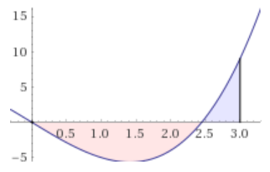
Therefore we can say that:

We then calculate:

So we say that .

Example 7: Let A be the area of the region that lies under the graph and above the x-axis of between .

- State the definite integral which is equal to A.

- Using right endpoints, find an expression for A as a limit.

We know the following:
Width of Rectangles | Right Endpoints | Height of Rectangles

Therefore we can say that:

Note: The limit in Examples 7 is difficult to calculate. With what we currently know we cannot evaluate this limit. We will need to develop some more sophisticated tools to deal with definite integrals like the one in this example.

